**Project Title: Drive Hassle-Free**

**Problem Specification:**

**Driving on Indian roads is a big task on its own because of peoples who don’t follow the existing, pedestrian’s, animals and what not. On top of all the mentioned issues there are other issues as well. There are police checkpoints on the roads where sometimes people are stopped unnecessarily and are told to show their documents which in some cases leads to challans and bribing and another issue being that people are now getting E-Challan**[**[1]**](https://echallan.parivahan.gov.in/index/accused-challan) **directly at their home on breaking speed limits and other rules with the help speed camera.**

**What we are making is an android applications which would give user notification to wear a helmet or seatbelt based on their decision and also alert the user before they enters an area which has speed cameras installed and also the areas which has a very high probability of having a check post so that they can slow down and can avoid unnecessary hassles that are faced while driving on the road.**

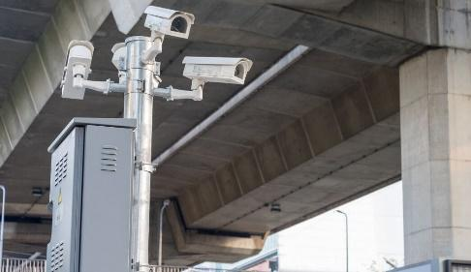 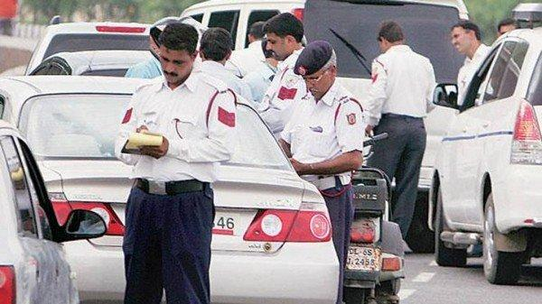 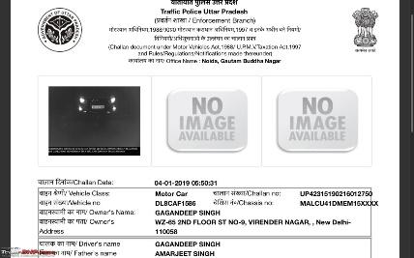

**EXISTING SYSTEM :**

**For all the features are not present in one single application that we are developing there are very few applications that are present but those applications are not yet available in India as such features requires resources from the individuals of that city moreover those applications doesn’t have the same features as ours and need to be all time screen-on which is risky while driving, and also by the time they inform its too late to do anything.**

**Drawbacks on existing systems :**

**1. People have to remember the locations on their own which is not very efficient as they are driving at the same time.**

**2. All the features are not present in one application hence people require more than two to three apps to do the things.**

**3. The application needs all time screen-on to work.**

**4. They are very risky as the user needs to screen to get the information which itself can cause a challan of using phone while driving.**[**[2]**](https://www.indiatoday.in/india/story/pay-rs-10-000-fine-for-using-mobile-phone-while-driving-in-uttar-pradesh-1706314-2020-07-31)

**5. By the time the application inform user its already too late for them to react to it and hence they are not very reliable and maybe slow as the inform on the particular saved location.**

**PROPOSED SYSTEM :**

1. **With the help of google map API user can know the exact location of the target and can be safe by the check post.**[**[3]**](https://cloud.google.com/maps-platform/maps)
2. **This application is built with the help of android studio and with help of this it will send alert message to the person.**[**[4]**](https://developer.android.com/training/notify-user/build-notification)
3. **In this application we are using geo-fencing which uses GPS, WI-FI or data to trigger a mobile device So that it creates virtual boundary to get the maximum area around the target.****[5]**
4. **Firebase is a platform that helps you quickly develop high-quality apps and grow your business.**[**[6]**](https://firebase.google.com)
5. **This application provides you a safe journey by reducing the traffic with the help of google map and reduce the chances of getting challans by sending the alert to follow the rule and regulation given by the Ministry of Road Transport before reaching the particular area.**[**[7]**](https://traffic-rules.com/en/india)

   

**ALGORITHM :**

1. **First, we find all the location which includes the fixed locations of the speed camera and highly, medium and low possible area where police usually set up the check post.**
2. **Then we save those locations coordinate with the probability in the firebase which is our database for the application.**
3. **We then call all the values from the database on starting the application then we also ask for the permission to use GPS from the user.**
4. **Then the locations are marked with different coloured Geofencing based on the possibility of having a check post.**
5. **User can close the application and it will run in the background and would notify the user based on the distance set for different possibility so that they don’t have to even look at the phone they can get notifications with a sound just like any normal application.**

**OBJECTIVE :**

**What we are trying to achieve is to give user a hassle-free driving experience and helping them avoiding any unnecessary problems while driving. We are helping them follow the rules by reminding them and also preventing them from getting possible chalans so that their money is not spent on challans and bribe.**

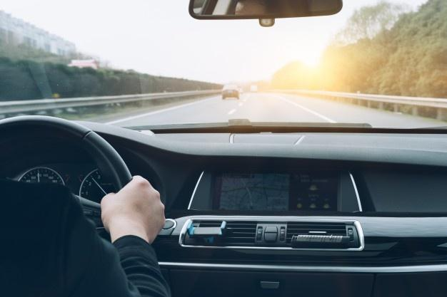

**CONCLUSION :**

**While driving people should follow all the basic laws that are being mentioned by the Ministry of Road Transport but it advised that your eyes should be on the road all the time so that you are able to react in case of an accident. To help people focus on their driving and to help them avoiding challans and other hassles of driving we have developed this application.**

**SCREENSHOTS :**

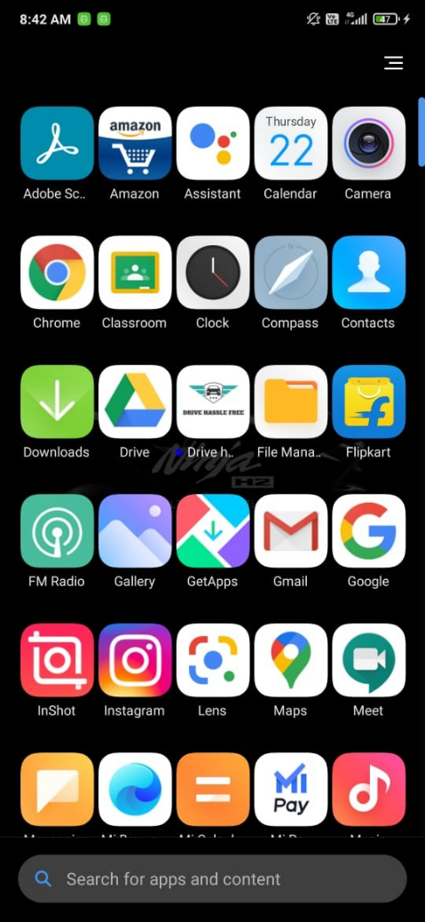 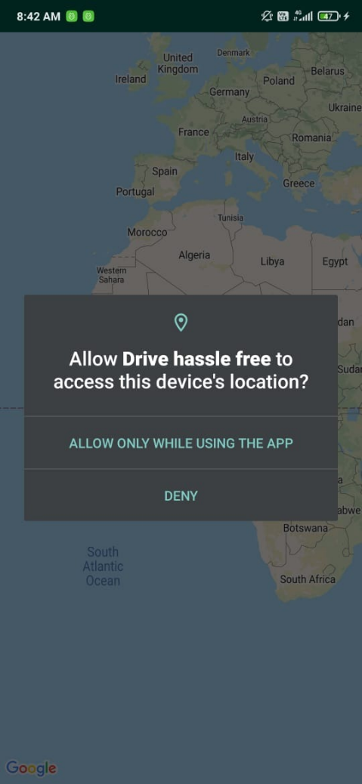

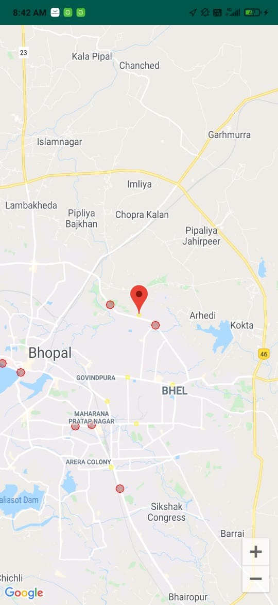 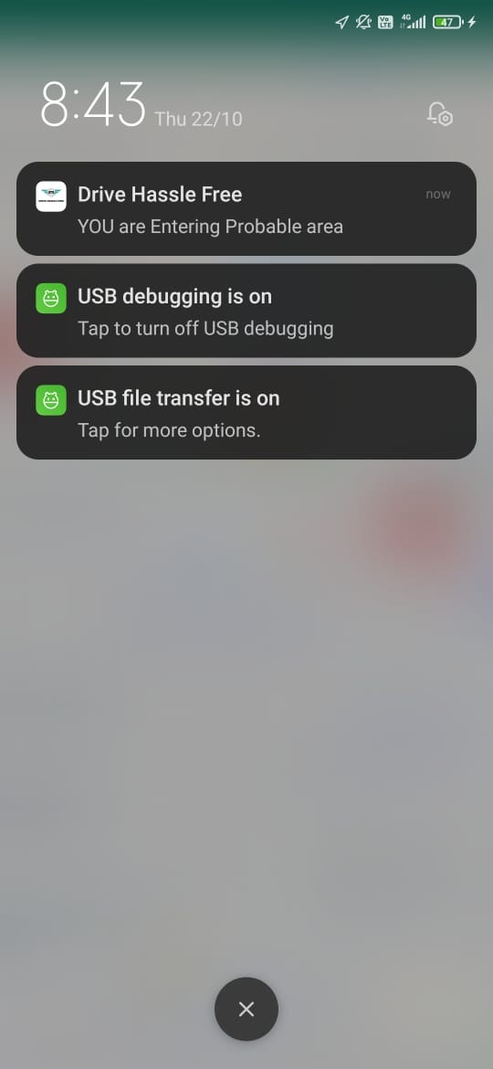 

**1.**

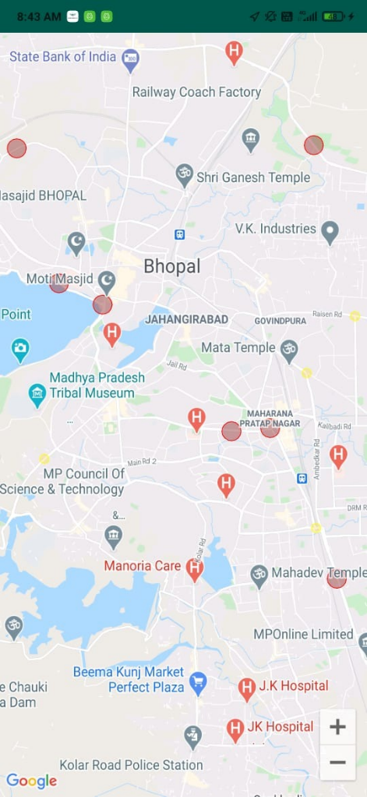 

**REFERENCES :**

**[1].**[**https://echallan.parivahan.gov.in/index/accused-challan**](https://echallan.parivahan.gov.in/index/accused-challan)

**[2].**[**https://www.indiatoday.in/india/story/pay-rs-10-000-fine-for-using-mobile-phone-while-driving-in-uttar-pradesh-1706314-2020-07-31**](https://www.indiatoday.in/india/story/pay-rs-10-000-fine-for-using-mobile-phone-while-driving-in-uttar-pradesh-1706314-2020-07-31)

**[3].** [**https://cloud.google.com/maps-platform/maps**](https://cloud.google.com/maps-platform/maps)

**[4].** [**https://developer.android.com/training/notify- user/build-notification**](https://developer.android.com/training/notify-%20%20%20%20%20user/build-notification)

**[5].** **https://geo-fencing&oq=geo-fencing**

**[6].**[**https://firebase.google.com**](https://firebase.google.com)

**[7].** [**https://traffic-rules.com/en/india**](https://traffic-rules.com/en/india)